The Adventures of Sam the Pirate

A Swashbucklin Studios Production

*Ash Crockett*

*Dustin Dos Santos*

# 

# 

*Contents*

The Pitch

Concept

Game Overview

Release Platforms

Reasons for Joining the Project

Ash

Dustin

Team Management

Team Creation

Team Members

Specialist Interest Area

Ash

Dustin

Project Planning

Project Goals

Milestones

Stretch Milestones

Marketing

Meetings

Research

Design and Development Tools

Project Management

Version Control

Programming Environment

Graphics and Input

Physics Libraries

Sound

Data Storage

Market Demographics

Legal

Social

Ethical

Game Design

Prototype

Narrative

Gameplay

Score, Collectables, and Time

Level Timing

Art Style

Art Layers

Concept Art

Characters

Levels

Environment Objects

UI Mockups

Controls

Game Flow

Menus

Gameplay

Overworld Map

Levels

Enemy Types

Artificial Intelligence

Level Design

Level Progression

Level Editor

Mock Up

Design Assumptions

Technical Design

References

# 

# The Pitch

## Concept

The Adventures of Sam the Pirate is a side scrolling 2D platformer game inspired by the likes of Super Mario Brothers, Super Meat Boy, and Rayman Legends. The game is targeted to be released on Steam.

The focus of the game is on platforming and avoiding environmental hazards, with some enemies throughout the game as an additional obstacle. There are coins to collect through the game, that contribute to the players score, as well as hidden collectables in each level.

## Game Overview

The player takes control of Sam the Pirate, as he wakes up one morning to find his ship wrecked, his crew mutinous zombies, and his precious treasure chest gone.

Sam is equipped with his pirate cutlass, to dispatch the enemies he encounters throughout his adventure. Coins are collected throughout each level that contribute to the players overall score, and Sam can find Barrels of Rum in each level, that act as a rare, hidden collectable and provide a substantial bonus to the score.

Levels are displayed on an overworld map that allows players to choose what order they want to progress through the game in. Completing a level acts as a checkpoint, and allows the player to come back to the game without losing their progress. If Sam dies during a level, that level must be restarted from scratch.

## Release Platforms

The targeted release platform is Steam Greenlight. Potentially it could also be released for PSP.

It could be given away free of charge, this is going to depend on what software/tools/libraries are used, and what their licenses are. This is completely fine, as at this stage of our careers, the marketing value and exposure from successfully putting a commercial quality game on a commercial platform while students is worth more than whatever money we could potentially make from it. It would also be good marketing for Media Design School, having students create a commercial quality product that is released on a commercial platform.

## Reasons for Joining the Project

### Ash

I have had the idea for this project in my head for over a year, really wanted to do it, even if that meant doing the programming side of the project myself. I want to make a polished, commercial quality product, and release it on a commercial platform.

### Dustin

I have tasked myself with the job of porting this game to sony PSP console as this project has the smallest scope. This helps mitigate risk in developing for the PSP as this project is likely to have additional difficulties during development that will leave porting the game a lower priority. An specialist for sony console development has advised that the workload will be split with 80% of the time required for research and learning the engine and architecture, leaving 20% left for actual porting of the game.

# 

# Team Management

## Team Creation

The process by which the creation of teams and projects were formed, began with a single directive; find a project that you want to work on and make it happen. This approach helped to generate teams and projects that people were committed/personally invested in developing. However, this took some time before the work flow became efficient and fully utilised, which usually manifested as time spent with conversions that were off topic half the time and the remainder was spent playing computer games (BattleField 3).

While this may have seemed like a waste of time I believe that it formed part of the Tuckman Model which involved the class getting familiar with each other and re-establishing familiar bonds within a relaxed environment.

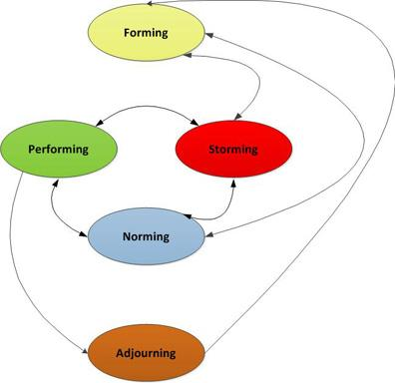

**Figure 1**: Tuckman Model [1]

This eventually made the creative process more interactive with class members bouncing ideas off each other and providing suggestions enriching these ideas. Over time this began to increase the level of discussions and people began to gravitate towards the projects that they liked. The presentations at the end of the week helped to answer any remaining questions by other class members who were on the fence with which project they would like to develop. This also helped the lecturers see the state of each idea and the progress made thus far.

The class then had the weekend and the monday morning to finalise their decisions and form the teams. The development of the teams happened quickly and the groups began planning and improving the game from their original concepts.

## Team Members

|  |  |  |
| --- | --- | --- |
| **Team Member** | **Roles** | **Justification** |
| **Ash** | Project Manager | * Currently has a high level oversight of the game requirements. * Has some experience managing other small projects. * Very organised. * Wants more experience in this area. |
|  | Lead Designer | * Is the original ideator and has the vision of what the game is going to be. * Has been thinking up the design for a whole year! * Is an open minded person and does not shutdown ideas. |
|  | Lead Programmer | * Has most experience developing 2D platformers. * Has some understanding of potential challenges and solutions. * Has already identified research areas. * Has already developed a suitable code framework for development. |
|  | Marketing Lead | * Has some experience developing a marketing campaign as part of curriculum. * Wants more experience in this field. |
| **Dustin** | External Contractor (PSP port) | * His chosen specialist area. |

## Specialist Interest Area

### Ash

My specialist interest area for this project is the overall game design, and business focused activities such as marketing and management. As I am looking to potentially start a game studio after graduation, or potentially during the later stages of the project, these areas are most interesting to me, rather than a programming specific area such as AI or networking.

### Dustin

# Project Planning

## Project Goals

* The team learns new development tools and methodologies.
* The game is fun to play.
* The game is published, or in the process of being published through the Steam Greenlight process by the end of May 2014.
* The game enables Ash to do a presentation on integrating Steamworks at next years New Zealand Game Developers Conference.

## Milestones

|  |  |
| --- | --- |
| **Date** | **Description** |
| End of Term 1 | All design documentation complete, including game design and an initial design for all 40 levels. |
| End of Week 4, Term 2 | Base rendering engine complete, including logging and input. |
| End of Term 2 | Platformer controls, physics, and UI framework complete. |
| End of Term 3 | Level editor complete, initial art implemented, initial levels created. |
| End of Week 4, Term 4 | Steamworks implemented, all levels created and being iterated over through user testing, tools for artists finished or being created. |
| End of Term 4 | Game has no critical bugs, is polished and ready to be published. |

## Stretch Milestones

These milestones are on the project plan, but there are currently no plans to implement them. If production goes well, and it becomes possible to implement one or more of them, then they will be looked at in further detail. They are listed in order of priority/feasibility for a single programmer.

* Global leaderboards - may require external servers.
* Level editor with Steam Workshop integration - may require external servers.
* Four player cooperative play.

## Marketing

As the game is planned to be released on Steam through the Greenlight process, there will need to be a fairly substantial amount of marketing work done in order to get awareness of the project out there, and hopefully encourage people to vote for the game on Steam. As part of the marketing campaign, the following should be actioned, or at the very least investigated:

* Get the Media Design School marketing team involved for most, if not all of the below steps.
* Write a weekly blog during production, possibly using a tool like WordPress. Post this blog to reddit, and other gaming related sites such as IndieDB.
* Be active on Twitter.
* During the beta, talk to active streamers on Twitch.tv and YouTube to see if there is any interest in streaming the game.
* Invite Gameplanet and/or NZGamer.com in to do a feature on the development. This would not be restricted to just this team, other teams could get involved as well. Potentially look at other avenues such as the New Zealand Herald/Stuff.co.nz as well.

## Meetings

Meetings will be held once a week on Friday afternoons at 2pm in the Level 19 Kitchen area. Agendas for these meetings will be emailed out to all involved on the Wednesday before.

Those involved in these weekly meetings include, but are not limited to:

* Ash
* Dustin
* Paul
* Art liaison, whatever their name is
* Artists

# 

# 

# Research

## Design and Development Tools

### Project Management

The agile project management software known as Hansoft will be used for this project. While the small team size means that there probably will not be much project management to do, as Hansoft is used in professional game development studios, it makes sense from a learning perspective to learn it now, so to be better prepared for the work environment.

It will be run on a remote micro Amazon Web Services server, as this is free for 12 months, and will allow team members to access Hansoft from wherever they are working.

### Version Control

GitHub will be used for version control, as it is free and widely used. This project is also an opportunity to learn a new form of version control, as the team has previously used TortoiseSVN.

The GitHub location for this project is <https://github.com/ash-c/pirategame>

### Programming Environment

Due to the school only having an academic license for the version of Visual Studio present, Visual Studio 2012 Express will be used instead, as it is completely free, and this would allow the final product to be sold commercially.

### Graphics and Input

SDL will be used in conjunction with OpenGL to handle input and rendering as it is distributed under the zlib license, which allows commercial distribution. These have been chosen over using DirectX, which the team is already familiar with, as it is cross platform, and allows the team to learn something new.

The artists will use Photoshop, and whatever other tools they may require, to produce the art. However this does bring up licensing concerns, as the school likely only has an academic license to Photoshop.

### Physics Libraries

Box2D is the planned 2D physics engine for The Adventures of Sam the Pirate as it is written in C++ and cross platform. Box2D has been chosen as the programming team has previous experience with it. Using a third party physics engine will mean that collision detection code will not have to be written manually, and opens up the possibility of interesting physics based mechanics.

Another option is the Bullet physics engine, which is supported by the Phyre Engine for PSP and PS3.

### Sound

FMOD is a premier sound engine, used in commercial projects around the world, however in order to release the end product commercially, even for free, requires a license. A casual license for a title with a budget of under $US100,000 costs $US500 for the first platform, and another $US500 for each subsequent platform. FMOD is also supported by the Phyre Engine for PSP and PS3.

FL Studio Fruity Edition can be used for creating music, it does not allow audio recording, but only costs $US99.

### Data Storage

Levels are represented as one single canvas, with the player viewing an area centered around Sam. Information such as each object's position and the object’s type need to be stored. All of this information will be stored as key/value pairs in a text file.

This information will be stored in the JSON format using one of the various open source JSON C++ interpreters. JSON has been chosen as it is a language independent data format, and the lead programmer and game designer has prior experience with JSON.

XML and INI files have been considered, however the team has a lack of experience with the XML format, and INI files have felt too simplistic for the task at hand.

## Market Demographics

The target demographic for The Adventures of Sam the Pirate is platformer fans of all ages. It is intended that anyone with an interest in platformer games may enjoy playing The Adventures of Sam the Pirate.

There are many popular platformers, both new and old, including Super Meat Boy, Sonic the Hedgehog, Commander Keen, Braid, Rayman Legends, Mark of the Ninja, to name a few. There are also some that have been successfully funded on Kickstarter.

* Mighty No. 9 <http://www.kickstarter.com/projects/mightyno9/mighty-no-9?ref=category>
* Legend of Iya <http://www.kickstarter.com/projects/523651724/legend-of-iya?ref=card>
* Tesla Breaks the World <http://www.kickstarter.com/projects/1660691250/tesla-breaks-the-world>
* Brave Bit <http://www.kickstarter.com/projects/1806980110/brave-bit-0?ref=card>

These successful Kickstarters and Super Meat Boy selling over 1 million units show that there is a consumer demand for platformers.

indie game the movie, tommy refenes making games for him, not others, selling well is a bonus, ~10mins into the movie

## Legal

All of the following legal issues will be finalised later on in the project.

Academic licenses for some software may mean that the end product will not be released commercially through Media Design School. Assuming IP ownership is held or transferred to the team creating the game, a Kickstarter campaign could be run after the project in order to fund the licenses required for a commercial release.

The other significant legal issue is the ownership of the IP. This is originally held by the school, which would prevent any commercialisation of the project after the team graduates. If the school is able to transfer ownership to Swashbucklin Studios at, or before the team graduates then the project could be commercialised.

Any external contractors that are bought in to produce sound effects and/or music will need a contract, to ensure they are either paid for their work when the project is commercialised. If the project is not commercialised, then these external contractors would need to volunteer their time, as there would be no money in the project.

There is no requirement for a classification rating to release on Steam Greenlight, however it is something that should be considered. There should not be any problems with the lack of a rating as Sam the Pirate would likely have been given a G or equivalent rating.

## Social

One of the social issues that has been noticed during development is that all characters in the game are male. Given how male dominated gaming in general is, with the lack of playable female characters, and instances such as Anita Sarkeesian’s successful Kickstarter campaign (<http://www.kickstarter.com/projects/566429325/tropes-vs-women-in-video-games>) to do a series of videos on women in video games, this seems like an opportunity to provide a female playable character. Potentially, some of the enemy types could also be female.

The downside to having both male and female characters is that it is an increase in workload for the artists. If the gender of each enemy type is decided after concept art is done, then the extra workload should not be that high, as the only extra art would be for the second version of the main character. Optionally, the main character could simply be female.

Doing so does require the name of the game to be changed, as Tim is a male oriented name. Options for name changes include Sam, Alex, and potentially any other gender neutral names that are thought of in the future. The name of the game could also be changed completely, to remove all references to a character name, and allow the male and female character to be have their own name and identity.

Another potential issue is how playable the game will be for people who suffer from colour blindness. This can be remedied somewhat by designing the colours appropriately for the different types of colour blindness. For example, avoiding mixing red and green colours together.

## Ethical

As the target audience for the game consists of people of all ages, the depiction of violence in the game and whether it is appropriate for younger gamers should be considered. As the intended art style is lighthearted and cartoony, death and combat animations should follow suit and not portray a realistic version of violence at all.

# 

# 

# Game Design

## Prototype

The prototype for The Adventures of Sam the Pirate was created in 2011, as part of a sprite game project using the Windows GDI framework. It is the inspiration for this project.

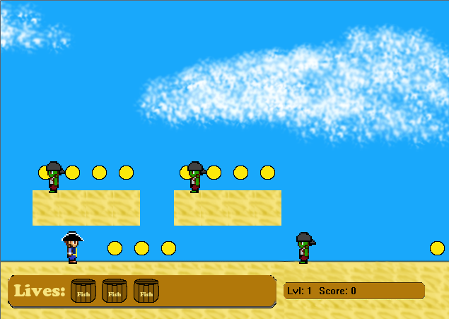

**Figure 2:** Screenshot of a beach level from the prototype.

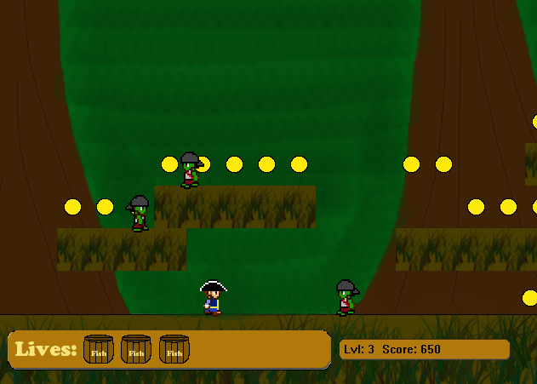

**Figure 3:** Screenshot of a jungle level from the prototype.

## Narrative

Sam the Pirate wakes up on his ship, the SHIP NAME HERE one morning, to find that his precious treasure chest which was stored under his hammock has been stolen! On his way to the deck, he discovers that his crew has turned into zombies! Upon reaching the deck, he sees his treasure chest in a row boat, being taken away by his former first mate, who is now leading the band of zombie pirates. These zombie pirates appear to be heading to a nearby island, so Sam heads over there on an adventure to get his precious treasure chest back.

## Gameplay

The focus of the game play is more on traditional platforming elements like running, jumping, and avoiding hazards, rather than combat. There will still be enemies, however combat with them is not the focus.

As such, Sam is equipped with a pirate cutlass for basic melee attacks in whichever direction he is facing. Any contact with an enemy or environmental hazard will kill him and force the player to restart that level from the beginning.

Rayman Legends is a good fit for what the game is intended to play like.

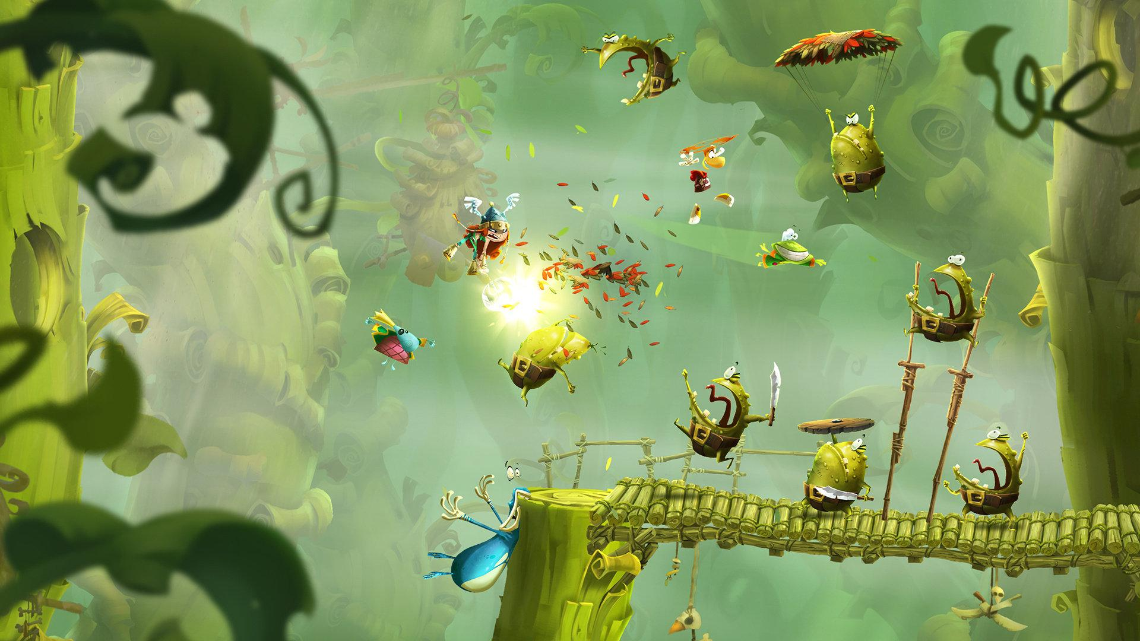

<http://www.technobuffalo.com/wp-content/uploads/2013/04/Rayman-Legends.jpeg>

## Score, Collectables, and Time

As they play through the game, the player earns points through various actions.

|  |  |  |
| --- | --- | --- |
| **Action** | **Description** | **Increase to score** |
| Pirate Coins | Scattered throughout each level. | 100 |
| Killing Enemies | Enemies scattered throughout each level. | 500 |
| Barrels of Rum | Rare collectables, a fixed number per level, some hidden, some more easily found. | 1000, Steam Achievement for finding the first one, all of the ones in a level, and all of the ones in the game. |
| Finishing a level. | Time how long the level took. | Add more score for a shorter time, maximum of 6,000. (10 minutes(600 seconds) times 10 points). |

Levels are timed in order to encourage speed, saving scores could also lead to doing global leaderboards based on score per level.

### Level Timing

Level timing is displayed to users in the format *minutes:seconds*, with the pure seconds value being used behind the scenes to determine how much score is added. Examples:

1. A level takes 10 minutes(600 seconds) to complete. 10000 - (600 * 10) = 4000, so 4000 is added to the players score.
2. A level takes 5 minutes(300 seconds) to complete. 10000 - (300 * 10) = 7000, so 7000 is added to the players score.
3. A level takes 20 minutes(1200 seconds) to complete. 10000 - (1200 * 10) = -2000, so nothing is added to the players score as the value is negative.

## Art Style

The art style for the game takes inspiration from games like the newer Super Mario Brothers and Super Meat Boy. The intent is for it to be cartoony, using bright colours and a relatively simple colour palette. The opposite of a game like Braid, where the art is quite detailed.

player/helpful objects - warm colours, bright?

enemies/harmful objects - cold colours, bright?

backgrounds - dull? saturated? not sure, opposite of bright so above stands out?

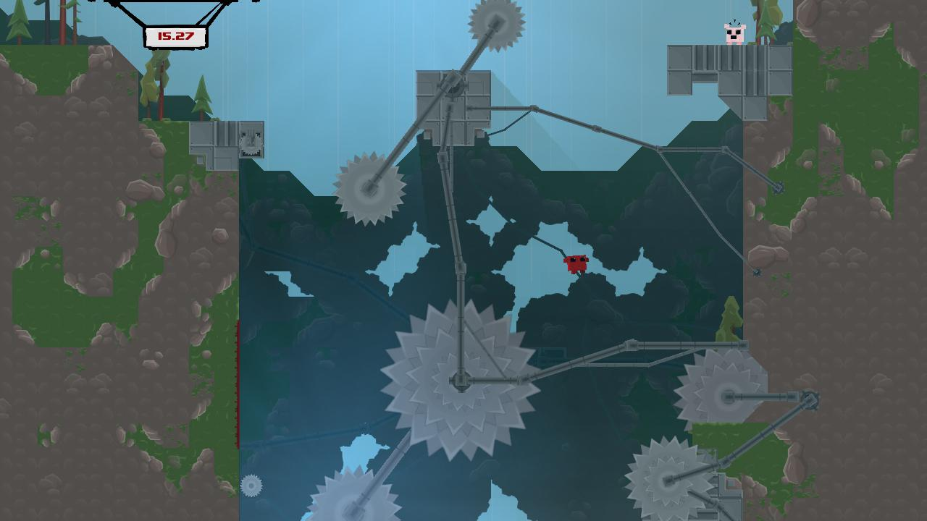

<http://supermeatboy.com/_media/meatboy/image/1269147440.jpg>

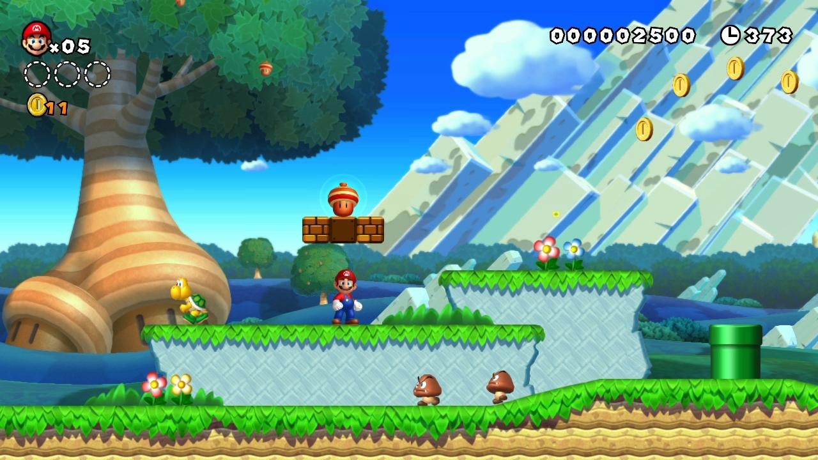

<http://gamersxtreme.org/wp-content/uploads/2012/12/New-Super-Mario-Bros-U-Gameplay-2.jpg>

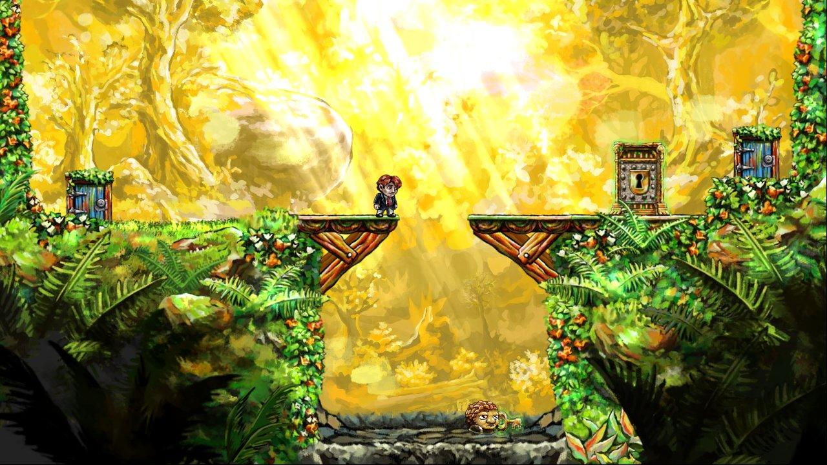

<http://images2.wikia.nocookie.net/__cb20100507135312/tig/images/5/52/Braid-screen01.jpg>

### Art Layers

Each individual level will contain multiple layers of art that can move independently of each other. The closer layers will scroll more than than the further away layers.

|  |  |
| --- | --- |
| **Layer** | **Description** |
| Far background. | Far off in the distance. Potentially just a static colour, clouds, hill, mountains etc. |
| Middle background. | Medium distance objects, trees/hills, clouds, etc. |
| Close background. | Close objects, trees, bushes, buildings, etc. |
| Level objects. | Sam , enemies, level platforms, environmental hazards etc. |
| UI. | The user interface, menus, score, etc. |

## Concept Art

### Characters

player character - male

player character - female

zombie pirates - male and female

zombie parrots

### Levels

inside/outside of a pirate ship

shipwrecks, ocean leading to beach

beach/sand

jungle

pirate fort

caves

### Environment Objects

carnivorous plants

swinging vines

rolling boulders

ladders?

spikes

swinging blades

torches + oil

spider webs

cannons

### UI Mockups

main menu

level

overworld map

options

high scores

## Controls

Input is open to change based on feedback from testing. All inputs are also customisable.

Default input for navigating menus/overworld:

|  |  |  |
| --- | --- | --- |
| **Action** | **Keyboard/Mouse** | **Controller** |
| Change selection/Move Sam. | Mouse movement, Up or Down arrows | Up or Down on the D-Pad or Left Analog stick. |
| Select item. | Enter. | A button on XBOX controller, Cross button on PSP. |
| Cancel. | Escape. | B button on XBOX controller, Circle on PSP. |

*Note: If the player uses a controller or the keyboard to navigate menus, hide the mouse cursor.*

Default input for moving Sam around each level:

|  |  |  |
| --- | --- | --- |
| **Action** | **Keyboard** | **Controller** |
| Move Left | Left Arrow | Left on D-Pad or Left Analog Stick |
| Move Right | Right Arrow | Right on D-Pad or Left Analog Stick |
| Jump | Up Arrow | A button on XBOX controller, Cross button on PSP. |
| Attack | Spacebar | B button on XBOX controller, Circle button on PSP. |
| Pause/Open Menu | Escape | Start on both controllers. |

*Note: Always hide the mouse cursor in levels, only display it if the menu is open and the mouse is moving.*

## Game Flow

### Menus

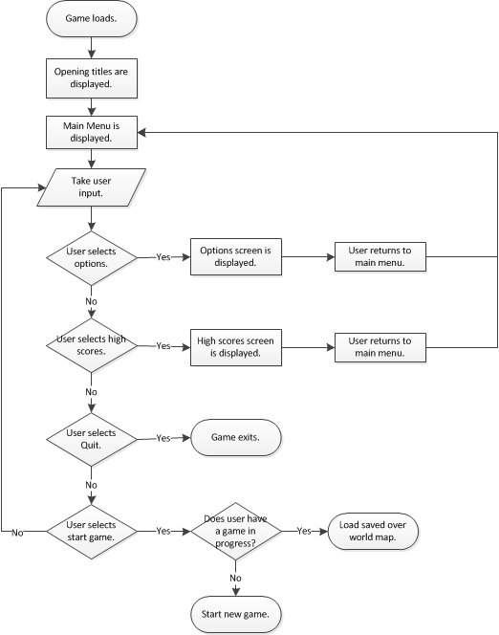

### 

### 

### Gameplay

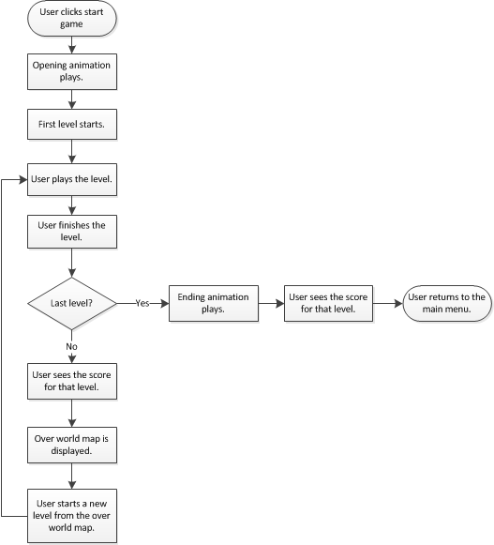

### 

### 

### Overworld Map

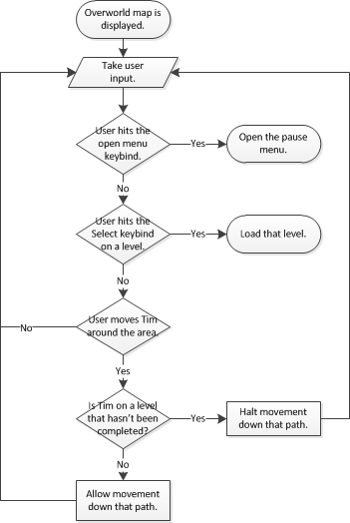

### 

### 

### Levels

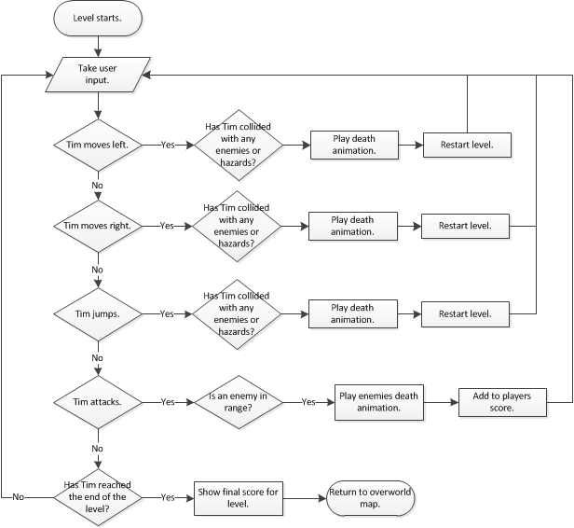

## 

## 

## Enemy Types

All enemies can only be killed with Sams cutlass attack. They all die in a single hit, in the same way that Sam dies in a single hit if he makes contact with any of them.

|  |  |  |
| --- | --- | --- |
| **Type** | **Description** | **Movement Speed** |
| Basic Zombie Pirate. | Melee attack with cutlass. | Medium. |
| Musket Zombie Pirate. | Armed with a musket for ranged attacks, and with a cutlass for melee attacks. | Medium, stationary when firing. |
| Cannon Zombie Pirate. | Mans a cannon. The cannonballs have an area of effect. Fires in an arc. | Stationary. |
| Shield Zombie Pirate. | Armed with a shield. Cannot be killed as the shield blocks all attacks. Does not have an attack of his own. | Slow. |
| Zombie Parrots. | Melee attack. | Flyer, high speed. |

### Artificial Intelligence

simple

spawn, move left as that’s direction player will be coming from

if hit wall or edge of platform, reverse direction

if player in line of sight, head in that direction

## 

## Level Design

Levels will have be 10,000 pixels wide by 2,000 pixels high, with the players screen essentially acting like a camera onto the level. Thus a smaller screen will display a smaller amount of the level.

The overworld map will be built in the same kind of fashion as the levels, but with a top down view. Movement will also be far more restrictive, with the player only being able to move along set paths.

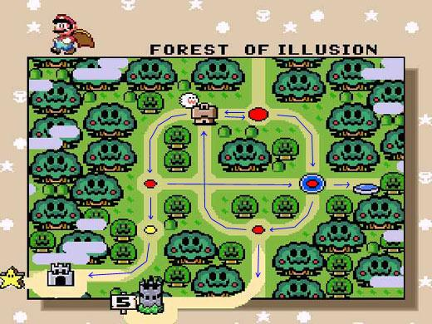

<http://forum.unity3d.com/attachment.php?attachmentid=63834&d=1376526627>

The overworld map provides a non-linear path through the game, allowing players to choose the levels they wish to beat to progress through the game.

BOSS FIGHT MECHANICS?

fight captain bwains but he escapes each time, except for the last time where he is defeated - but not killed?

boss level = a race to the end?

### Level Progression

|  |  |  |  |  |
| --- | --- | --- | --- | --- |
| **Levels** | **Theme** | **Enemies Introduced** | **Hazards Introduced** | **Other Elements** |
| 1 | Ship. | Basic Zombie Pirates. | Fire. |  |
| 2 | Ship to Beach. |  | Sharks, water (Sam can not swim). | Floating platforms moving with the water current. |
| 3-10 | Beach. |  | Quicksand. | Sand dunes can be slid down. |
| 11-20 | Jungle. | Musket Zombie Pirates and Zombie Parrots | Carnivorous plants. | Swinging vines. |
| 21-30 | Pirate Fort. | Cannon Zombie Pirates. | Spikes, swinging blades, unstable platforms. | Unused cannons, use to create entrances to secret areas. |
| 31-40 | Caves. | Shield Zombie Pirates. | Falling boulders, lava, spider webs, torches and oil. |  |

## Level Editor

The level editor will be built using the game engine. Its layout will be user friendly and aimed at an end consumer, rather than a developer perspective, as one of the stretch milestones is to release the editor with the game and Steam Workshop integration.

how level information stored? tile based or allow platforms/walls to be placed anywhere

leaning towards tile based

### Mock Up

ui layout

## Design Assumptions

Assumptions impacting on the design process are noted and discussed.

# 

# 

# Technical Design

# References

[1]: **Title**: Group Dynamics and Project Teams, **Author**: Kathy L. Maschke, **Date Accessed**: 26/08/2013, **URL**: <http://www.kennesaw.edu/businessservices/Sept2011News/PMO_001.html>